Chapter 2

***Virtual Reality***

2.1 Introduction

Virtual Reality (VR) is the use of computer technology to create a simulated environment. Unlike traditional user interfaces, VR places the user inside an experience. Instead of viewing a screen in front of them, users are immersed and able to interact with 3D worlds.

The idea of VR is quite old as the first headset was created in 1968, But as computing power is more advanced now more than ever many companies are making games and application specifically for VR and it is a profitable industry.

2.2 Why VR?

As VR puts the user in immersive 3D world and incorporates all the user’s senses, it seemed to be the most appropriate environment for users to practice their speech in to be as replicative to real life as possible.

The target is create a room similar to a lecture hall with audience that the user can interact with via his speech and they give a feedback on the user’s speech or lecture.

2.3 Headsets

There are many headsets available for VR applications; they range in size, price and capabilities like HTC vive, Oculus Rift, Samsung VR and Google Cardboard. We can separate head into two categories based on their features.

* Oculus/Samsung/HTC

They are expensive in the range of 500$ or higher, they offer more features like Degrees of Freedom that the user is allowed to move in. They are also able to detect the user’s position in the room via sensors scattered in the surrounding environment. They also must be connected to a computer for computing and the image is transferred to the user’s headset. Fig 2.1 shows a simple room setup for these kind of headsets.

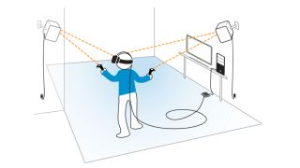

**Figure 2.1** Room Setup

* Google Cardboard

It is very cheap in the range of 10$ or less. It does not have any of the features discussed above from detecting the user’s position. It’s only one feature is the simplicity it offers compared to the much more expensive options. It is a holder for a mobile device and blocks light from the environment giving the desired feeling of VR. Fig. 2.2 shows Google Cardboard.

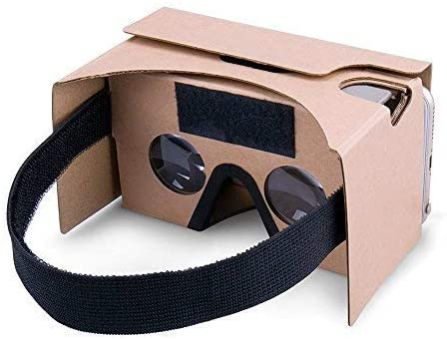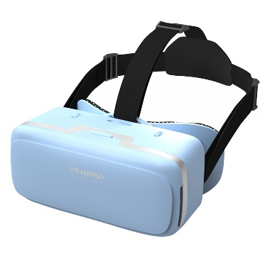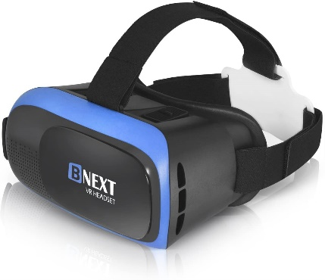

**Figure 2.2** Google Cardboard / Alternatives

Considering the simplicity and prices of cardboards, it seemed to be the appropriate option to go with for our application since everyone could get it without paying so much a gadget they might not use much.

2.4 VR Development Issues

Although VR seems a great and fun experience, it also has it issues as the user has to wear the head for a long period, which can cause some discomfort to users. VR issues are eyestrain, nausea and motion sickness since the senses are not used to that kind of new experience.

It is the job of developers to handle those issues and make the application as eye pleasing as possible with no lagging or frame rate fluctuations, which are the main reasons of the discomforts, stated previously. Suitable frame rate is usually 60+ FPS and the quality of the objects should be clear as possible for the most pleasing experience.